SURGE PROJECT

Name: Aravind Seshadri

Roll No: 210180

Assignment 1: Simulating a Path Following Robot in V-REP/CoppeliaSim

* Creating a path: First, a path was created for the robot to follow. This included adding multiple points to the path to extend it. This path was named ’Path’.

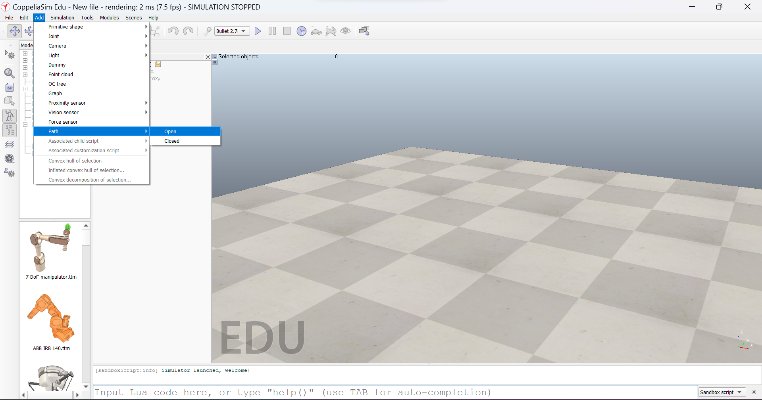

Additional Points are added by copying and pasting a particular given point and then dragging the new point to another location or entering its coordinate.

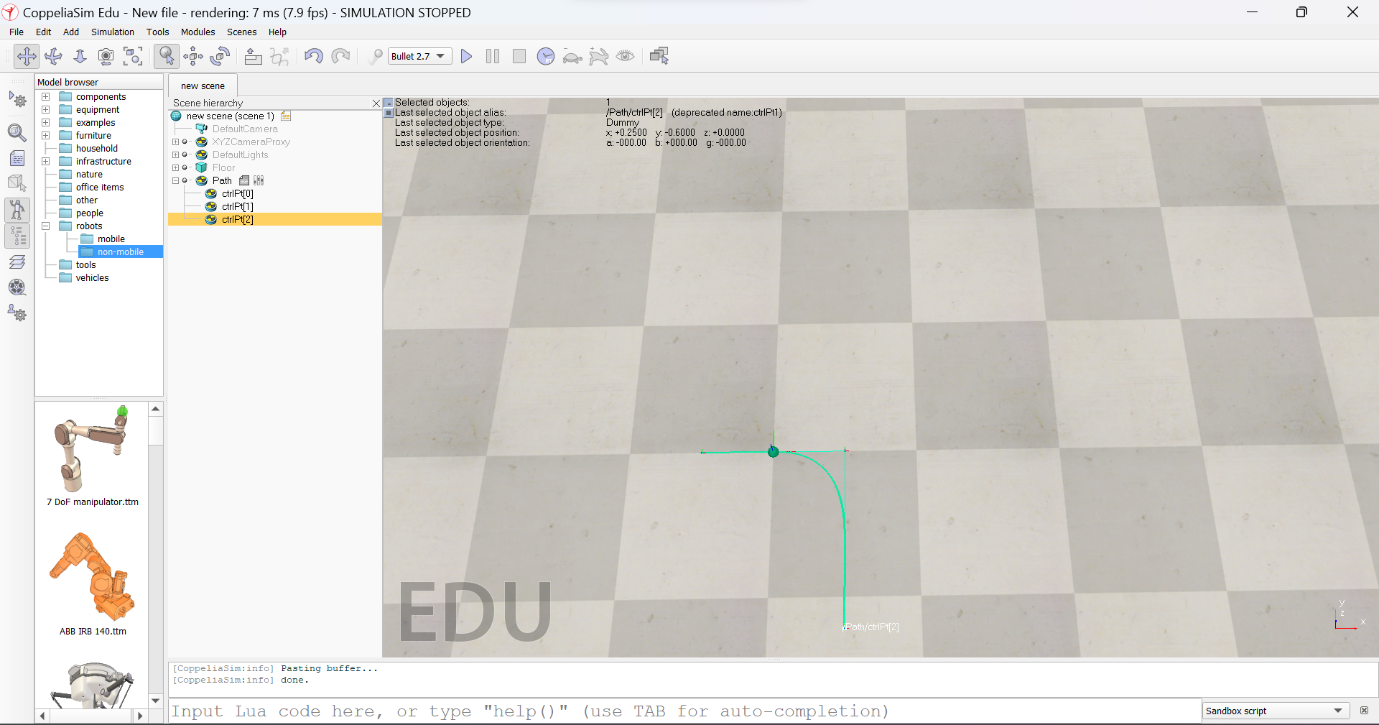

* Adding the dummy: A dummy was added to the scene to observe its motion along the path

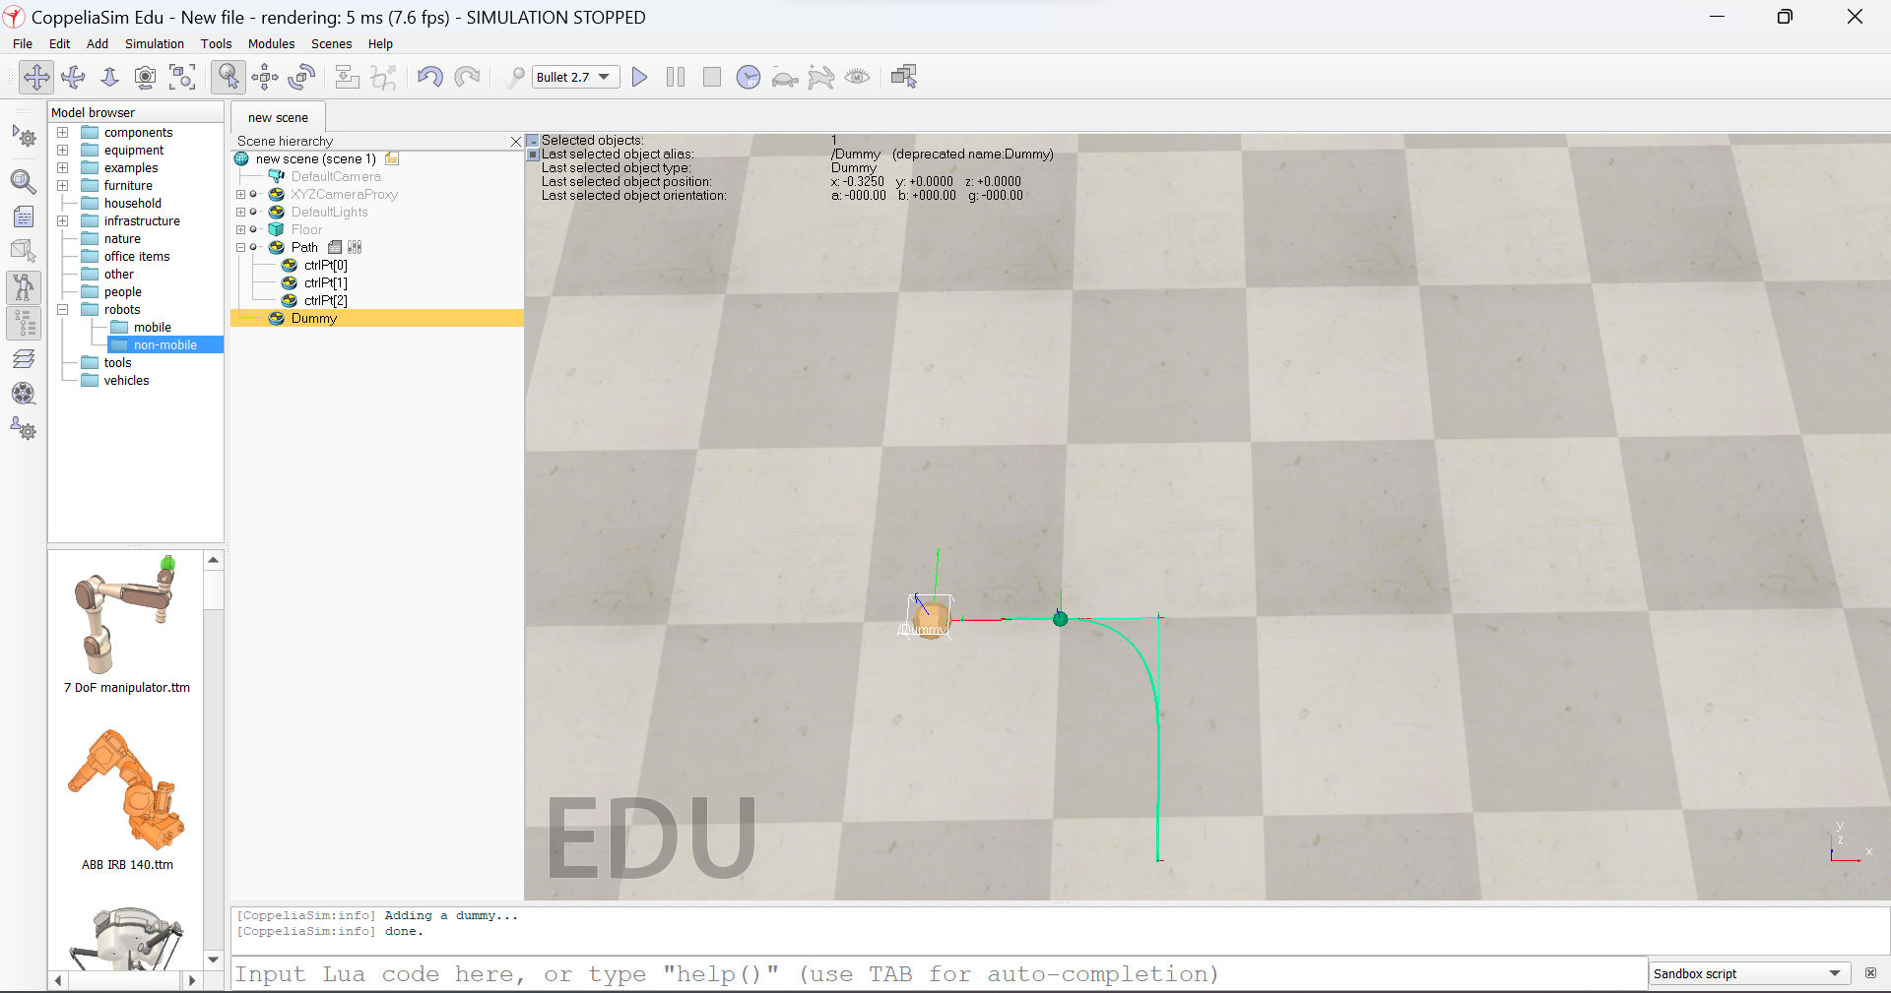

* A threaded Associated Child Script was added to the dummy

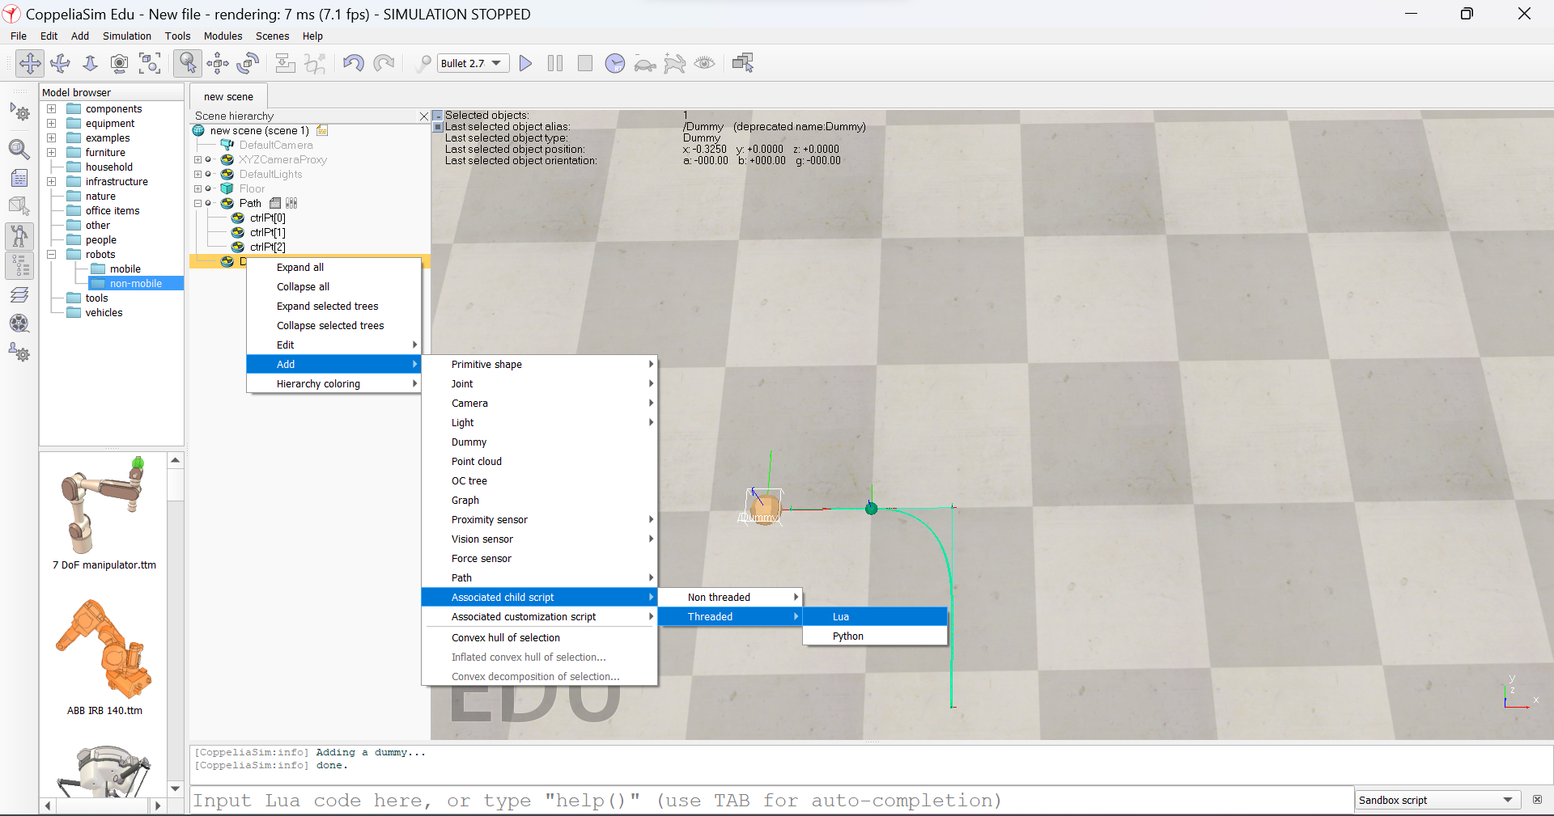

* The following code was written in the script:

function sysCall_threadmain()

local thisObjectHandle =sim.getObjectAssociatedWithScript(sim.handle_self)

local pathHandle=sim.getObjectHandle(‘Path’)

local changePositionOnly=1

sim.followPath(thisObjectHandle, pathHandle, changePositionOnly,0,0.17,15)

end

Here thisObjectHandle refers to the current object. In this case, the dummy and pathHandle refer to the path added to the scene.

* Adding the code: However, in the latest version of CoppeliaSim(V4.4), the function sim.followPath was deprecated. Hence, we use an alternate code for path planning

function sysCall_init()

cube=sim.getObject('.')

path=sim.getObject('/Path')

pathData=sim.unpackDoubleTable(sim.readCustomDataBlock(path,'PATH'))

local m=Matrix(#pathData//7,7,pathData)

pathPositions=m:slice(1,1,m:rows(),3):data()

pathQuaternions=m:slice(1,4,m:rows(),7):data()

pathLengths,totalLength=sim.getPathLengths(pathPositions,3)

velocity=0.05 -- m/s

posAlongPath=0

previousSimulationTime=0

end

function sysCall_actuation()

local t=sim.getSimulationTime()

posAlongPath=posAlongPath+velocity*(t-previousSimulationTime)

posAlongPath=posAlongPath % totalLength

local pos=sim.getPathInterpolatedConfig(pathPositions,pathLengths,posAlongPath)

local quat=sim.getPathInterpolatedConfig(pathQuaternions,pathLengths,posAlongPath,nil,{2,2,2,2})

sim.setObjectPosition(cube,path,pos)

sim.setObjectQuaternion(cube,path,quat)

previousSimulationTime=t

end

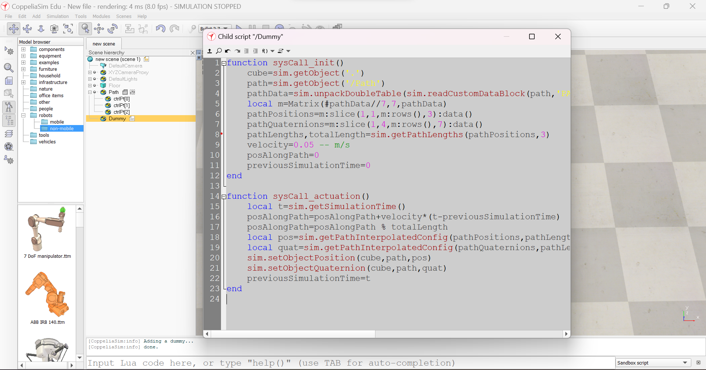

After adding the code the simulation was started and the dummy was observed to move along the path.

* Next, the same procedure is implemented for any other object, such as a cuboid.
* After this, the same procedure was implemented for a drone model Quadcopter. This was added to the current scene by importing it from the given list of models under mobile robots.

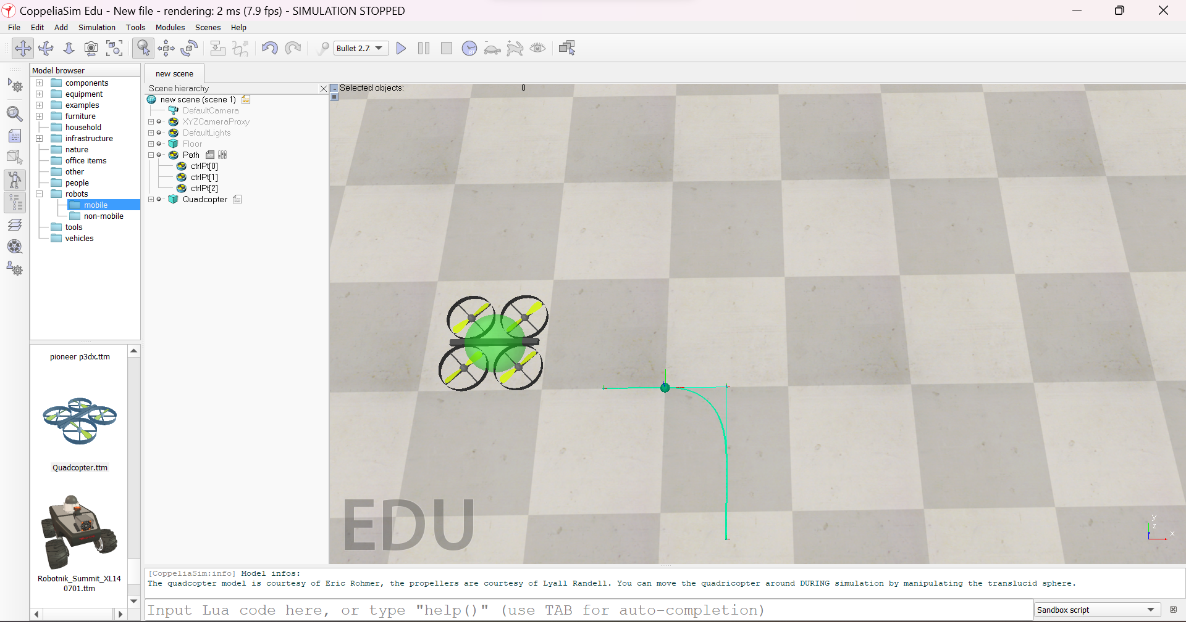

* For this, we add an associated child-threaded script to the target of the Quadcopter model. On running the Simulation, the Quadcopter model follows as the target is moved. We use this property of the model to enable the Quadcopter to move along the path.

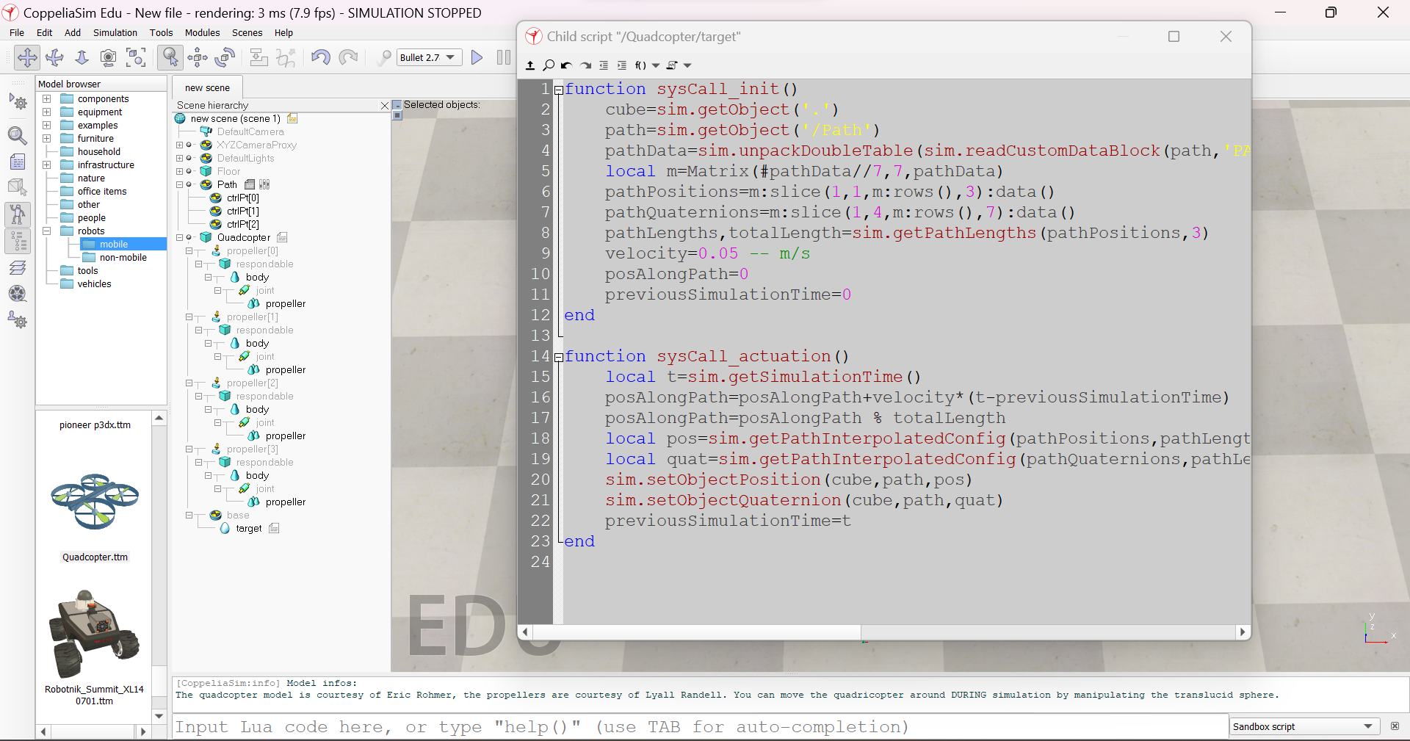

* The code is added to the target script of the Quadcopter, and the simulation is run.
* It was observed that the Quadcopter moved smoothly along the path.
* The Quadcopter location was shifted to the beginning of the path to give it a smooth start. Following is the observed motion of the Quadcopter.

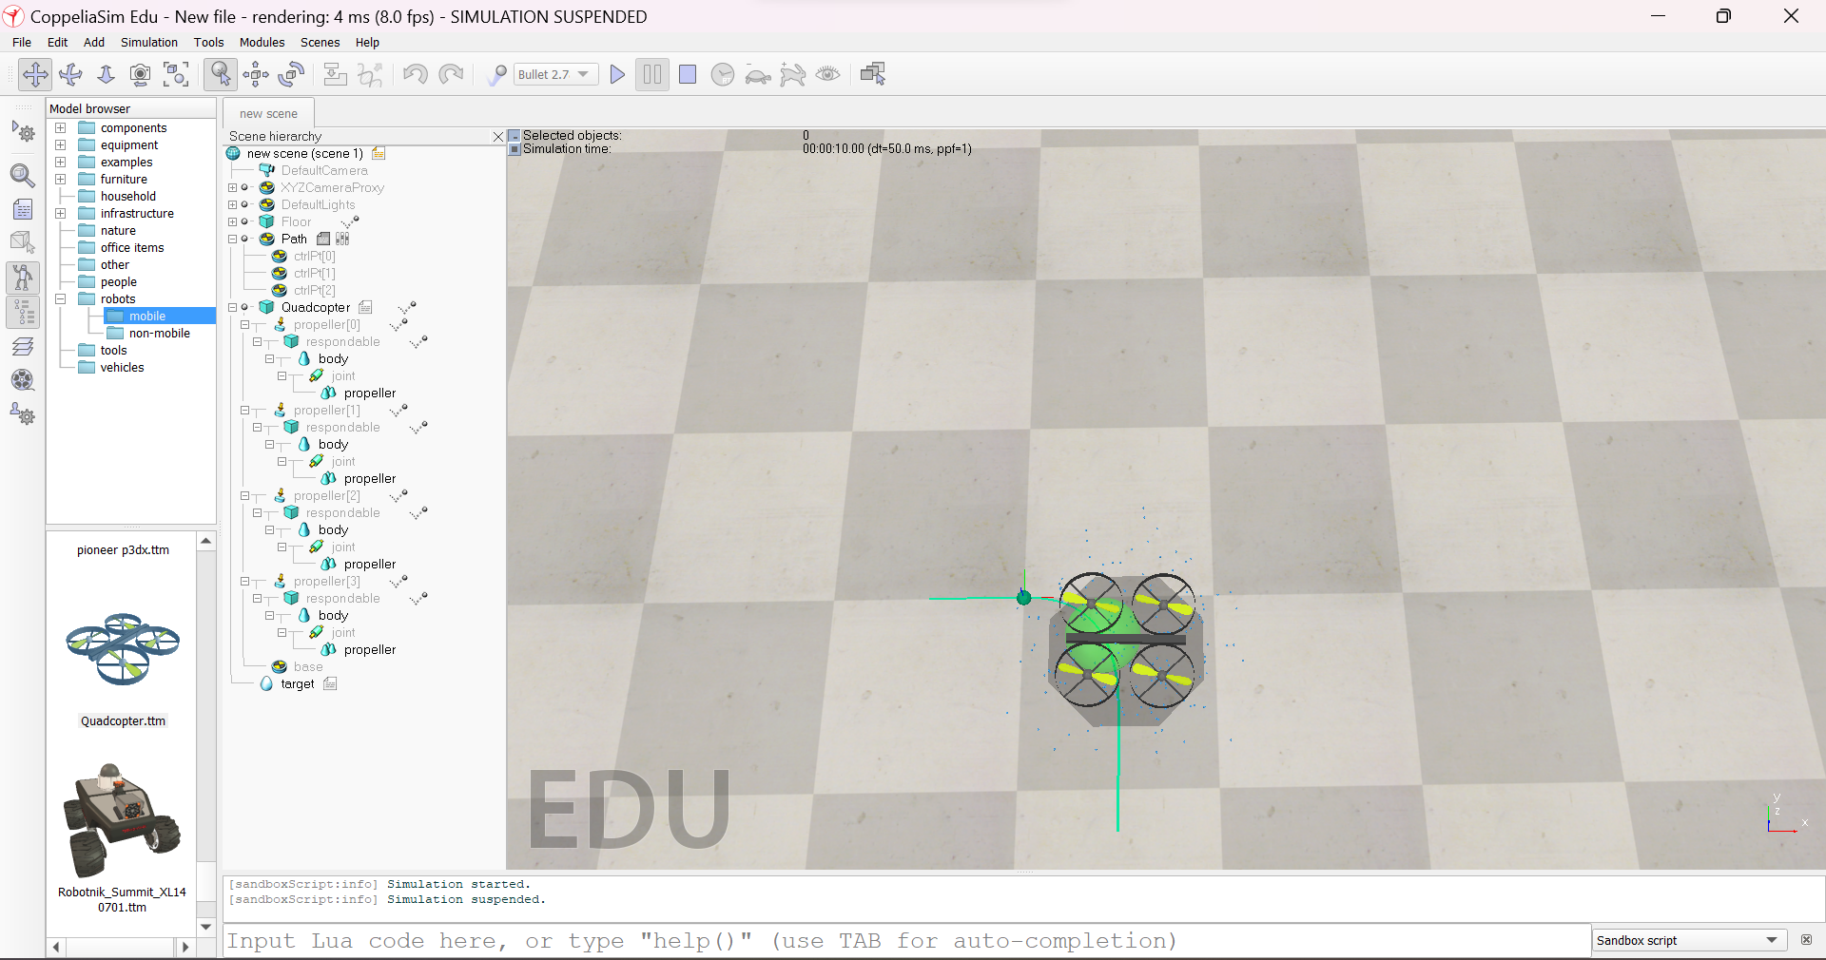

* Many other demo simulations were also run for different scenes. The following is an example of a demo simulation. This can be accessed by scenes/movingAlongAPath directory in Coppeliasim. Here the motion of multiple objects is observed along a path.

